# 001.Git Fork:

-- How to fork a project?

-- A fork is a copy of project.

-- When forking a project or repository, allows you to make changes with out affecting the original project.

## Step-1:

Login to your gitlab nd go to your project

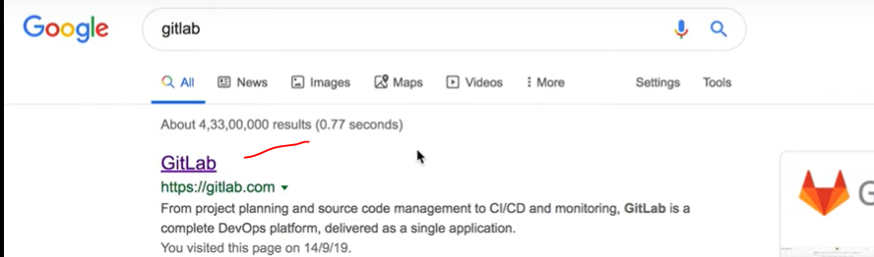

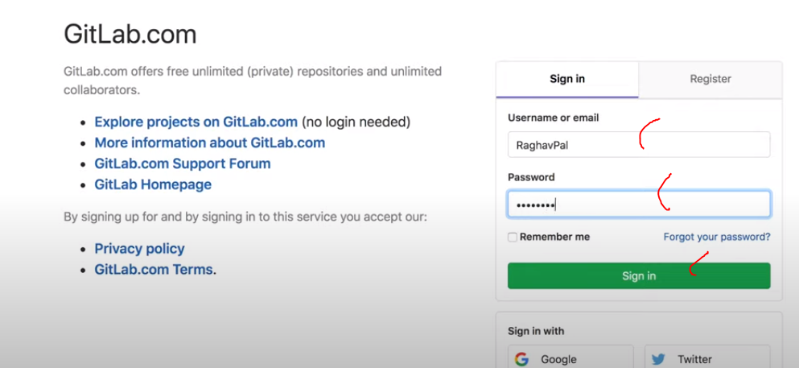

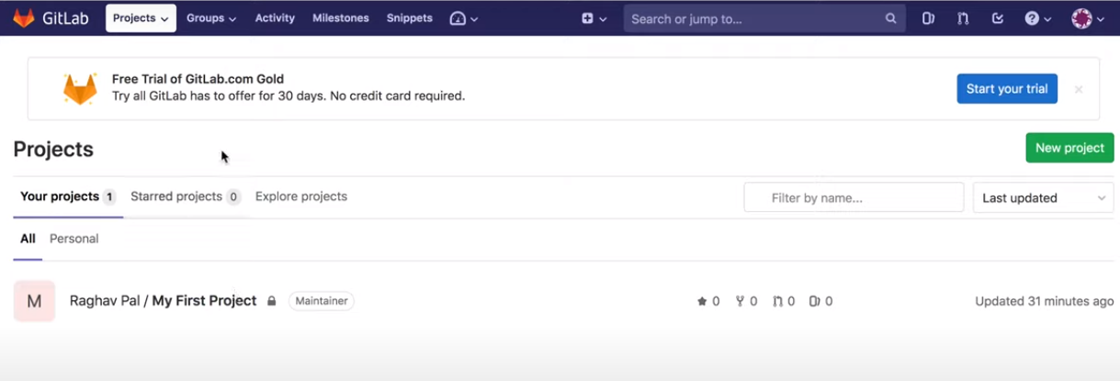

click on My First Project

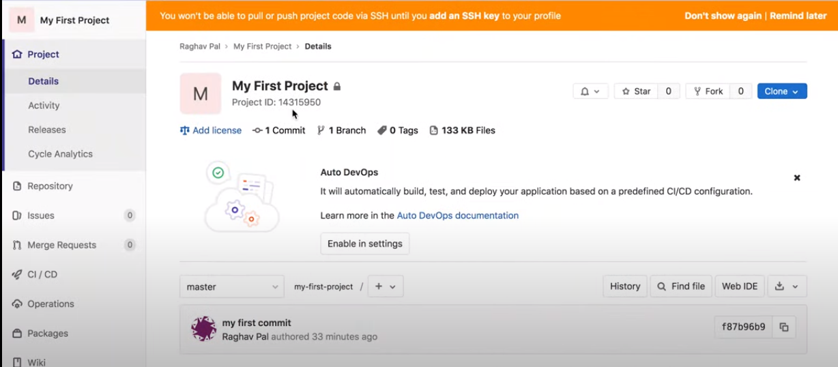

## Step-2. click on fork button

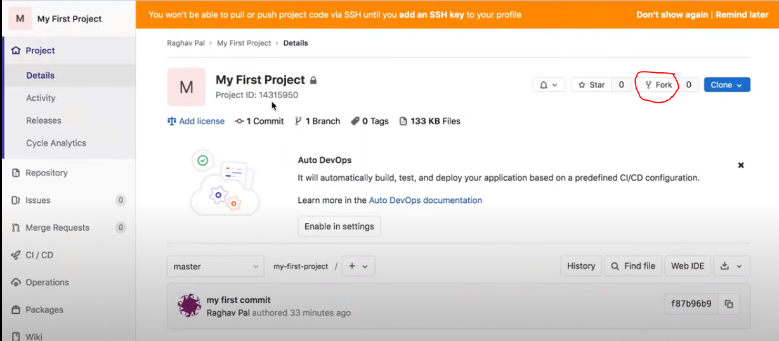

now searching for namespace/group to fork the project, if it is not available name space create name space/ group.



click on groups in menu bar--> click on your groups --> it moves to another screen.

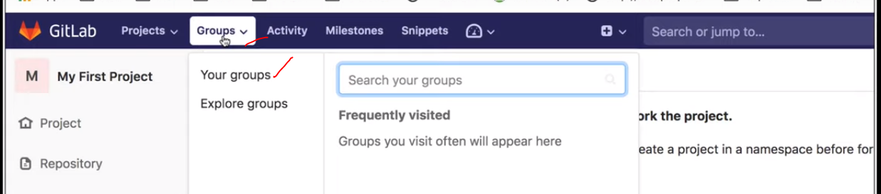

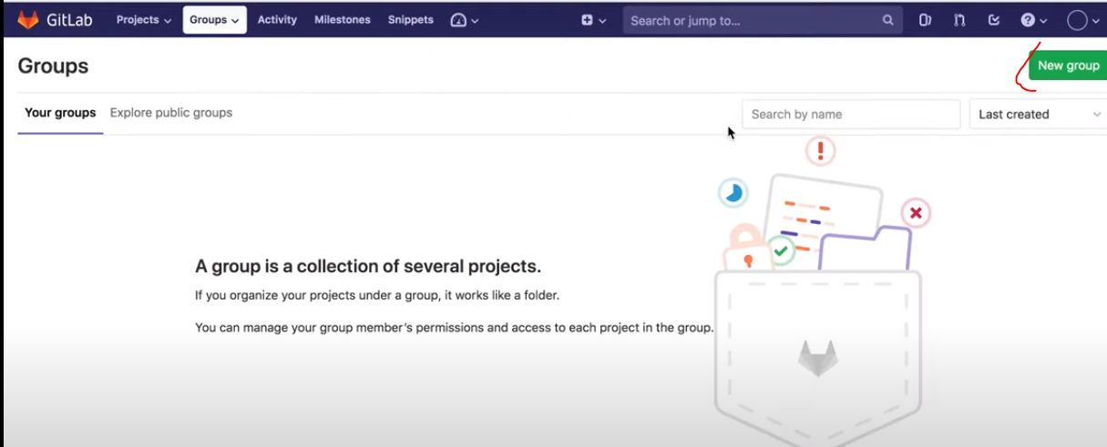

click on new group button

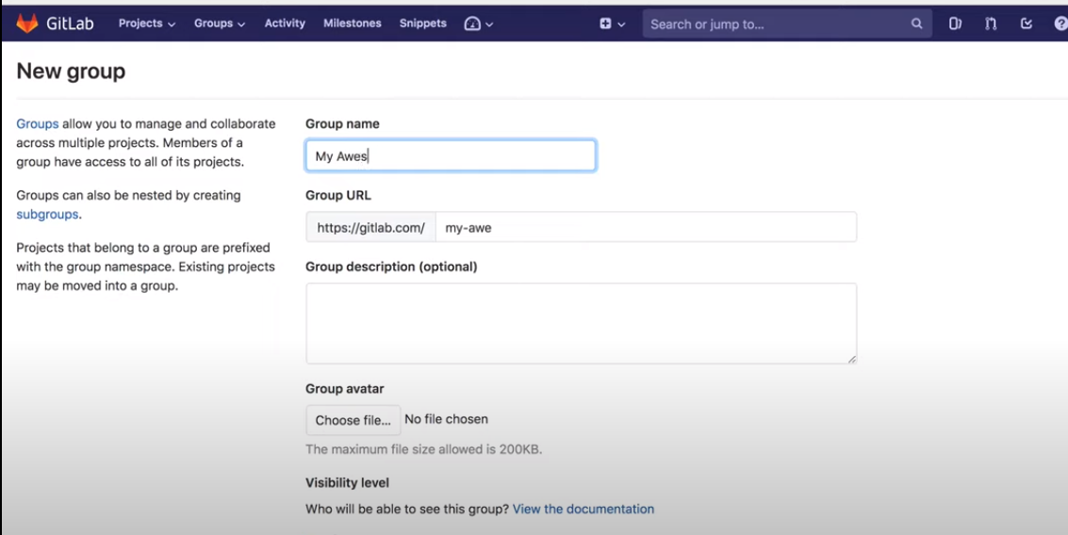

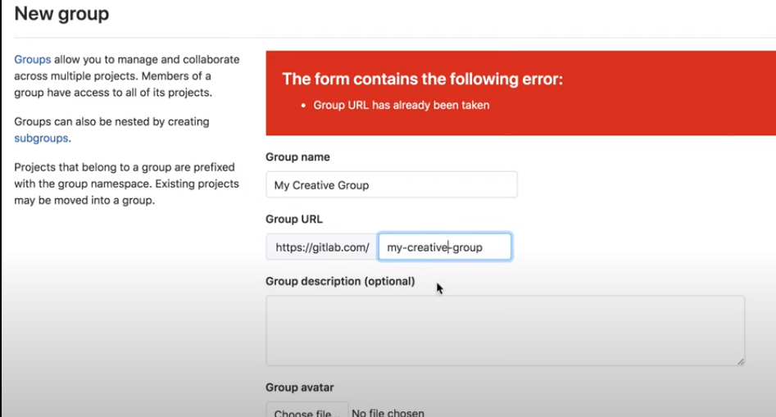

click on create group.

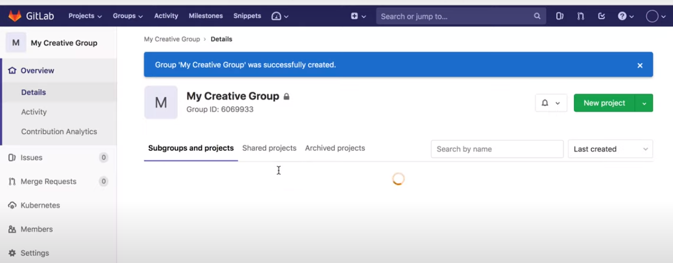

group created

Now go back to our project.

in menu bar click on projects-->your projects.

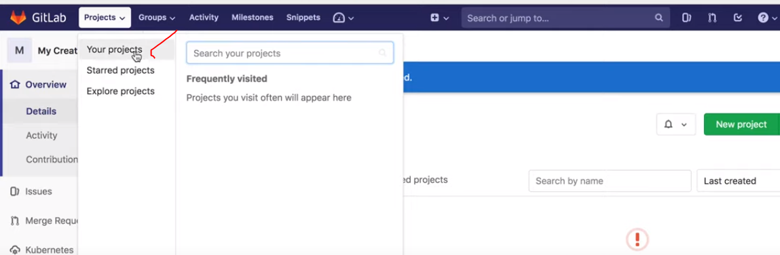

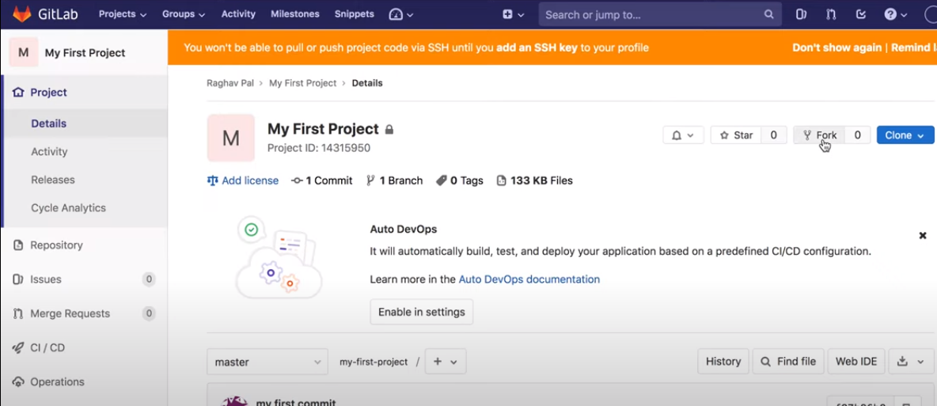

click on fork.

it will redirect fork project page,

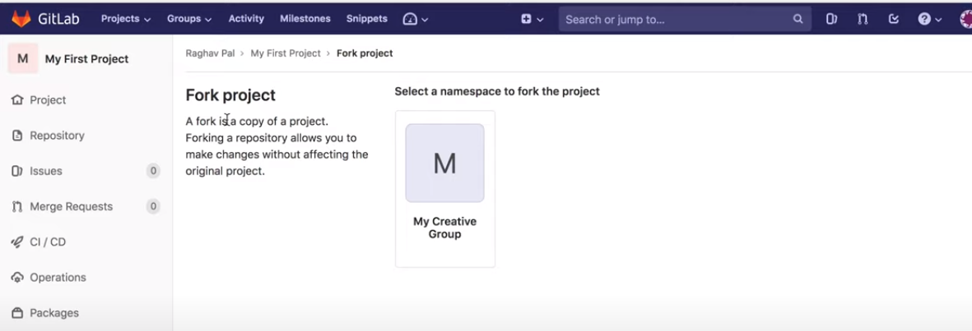

click on my creative group

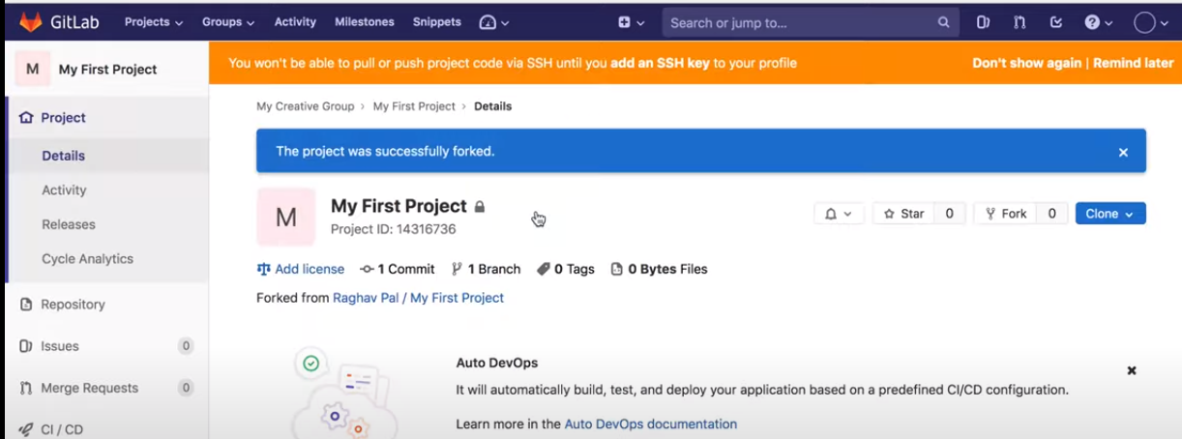

now project forked succesfully.

now on the copy of the project(forked)--> make some changes, once done with my changes --> i can create merge request to merge my changes with original branch.

create merge request:

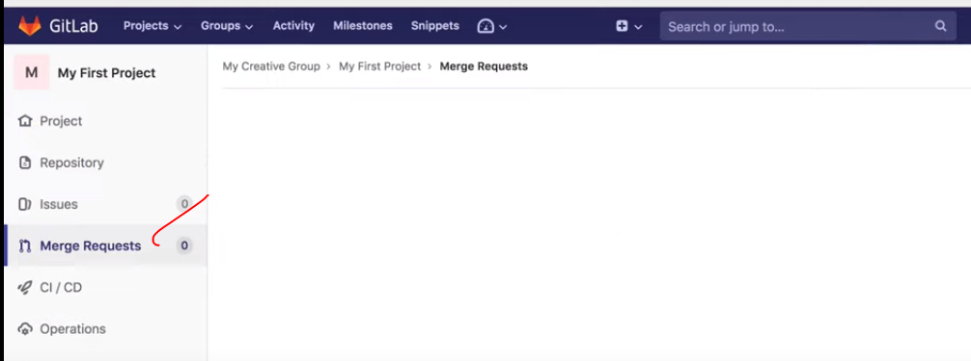

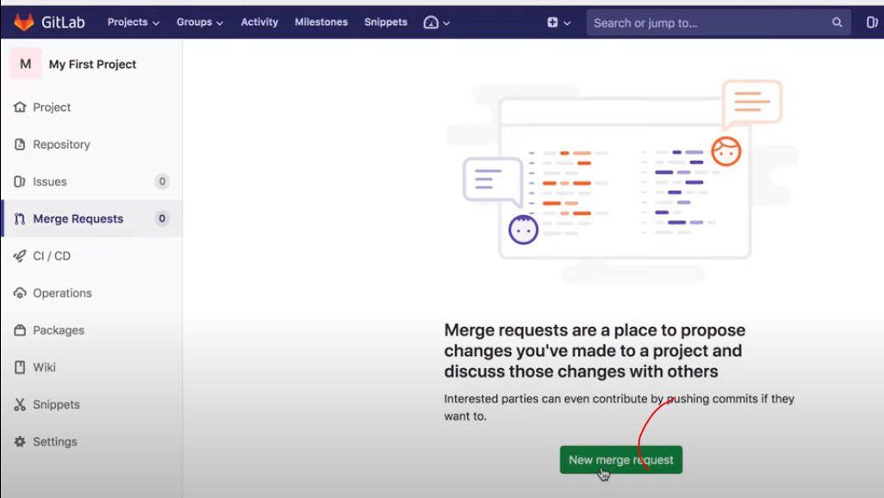

click on merge request.

in next page select the source and target branch

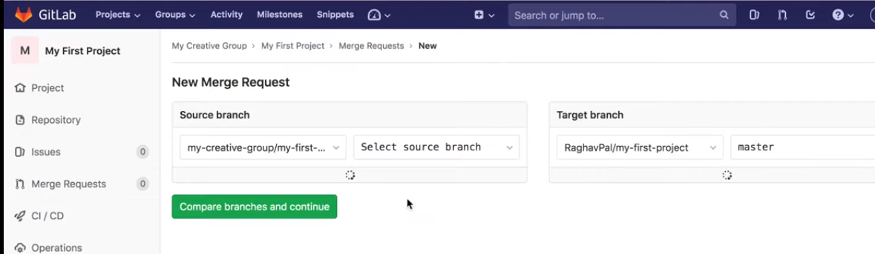

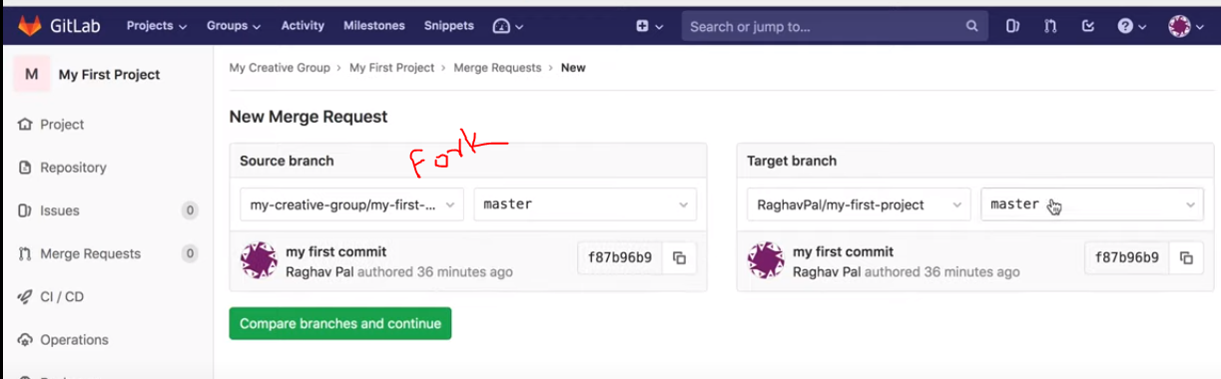

click on compare and continue

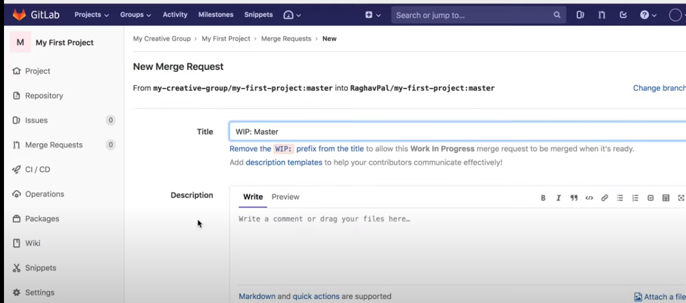

if there will be any changes will be compare and shows to here, as of now there is no changes

click on submit the merge request.

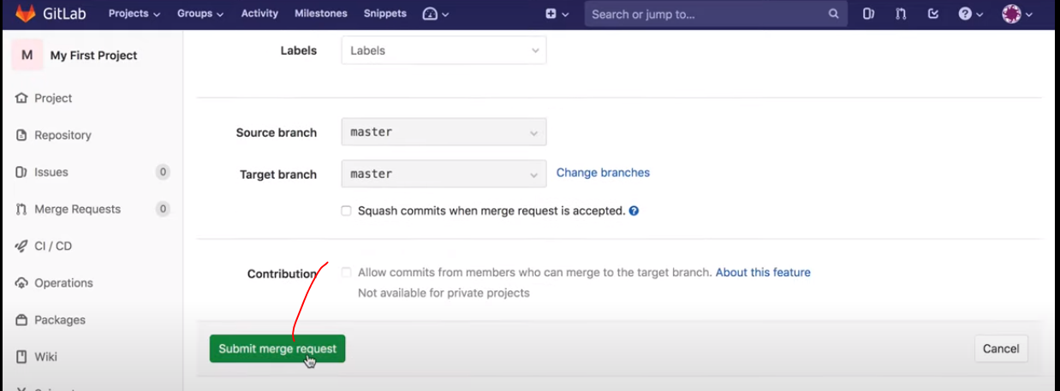

now analyzed the changes and submit it and back.

